Runge-Kutta results
Stencils are
GETLM: [(-2,-1,0,1), (-2,-1,0,1), (0)]
IETLM: [(-2,-1,0,1), (-2,-1,0,1)]
LETLM: [(0),(-8,-7,-6,-5,-4,-3,-2,-1,0,1,2,3,4,5,6)]

Results:
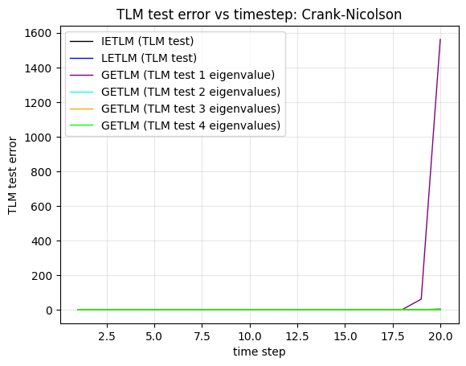
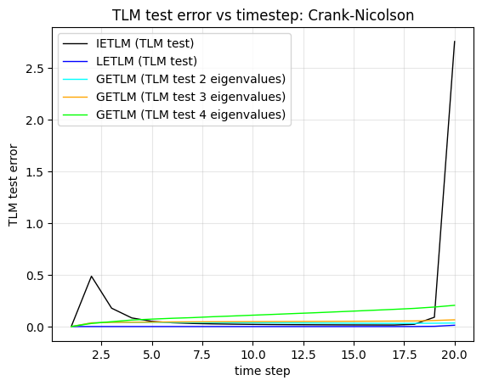
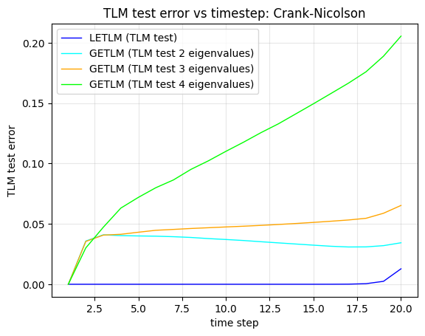
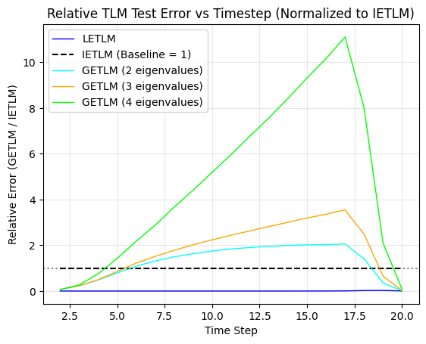
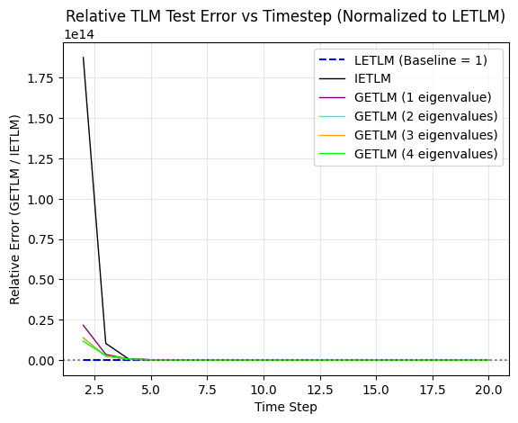
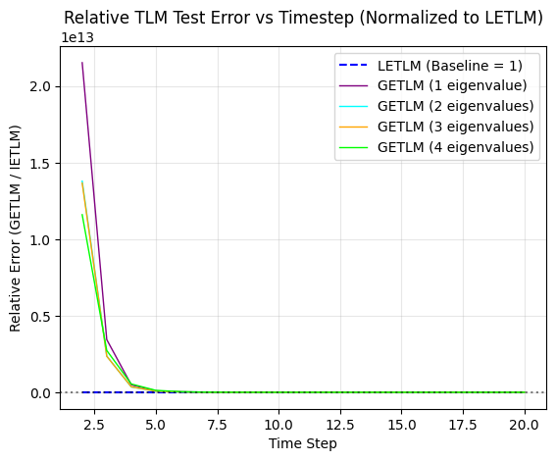

Runge-Kutta results
Stencils are
GETLM: [(-2,-1,0,1), (-2,-1,0,1), (-2,-1,0,1)]
IETLM: [(-2,-1,0,1), (-2,-1,0,1)]
LETLM: [(0),(-8,-7,-6,-5,-4,-3,-2,-1,0,1,2,3,4,5,6)]

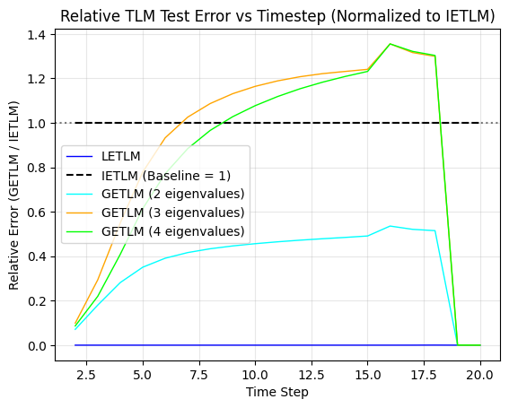
Runge-Kutta results
Stencils are
GETLM: [(-2,-1,0,1), ),(-8,-7,-6,-5,-4,-3,-2,-1,0,1,2,3,4,5,6), (-2,-1,0,1)]
IETLM: [(-2,-1,0,1), (-2,-1,0,1)]
LETLM: [(0),(-8,-7,-6,-5,-4,-3,-2,-1,0,1,2,3,4,5,6)]
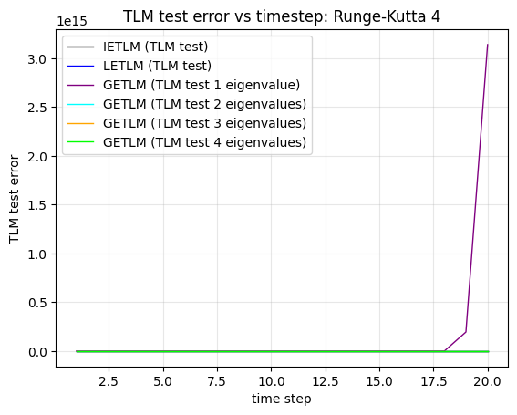
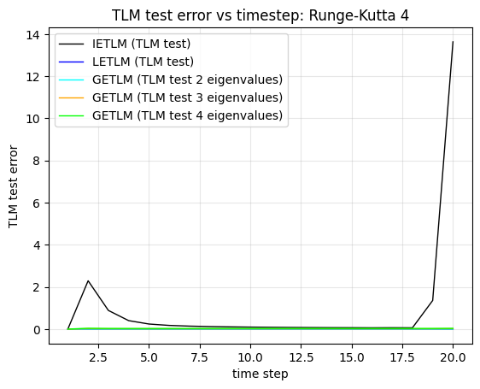
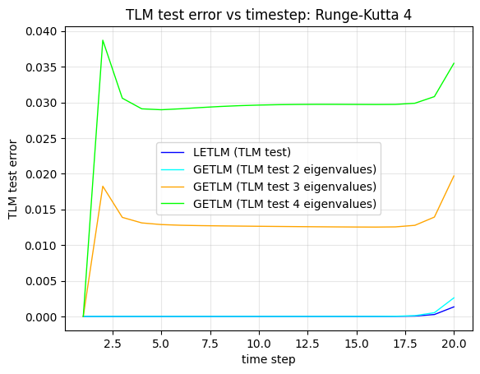
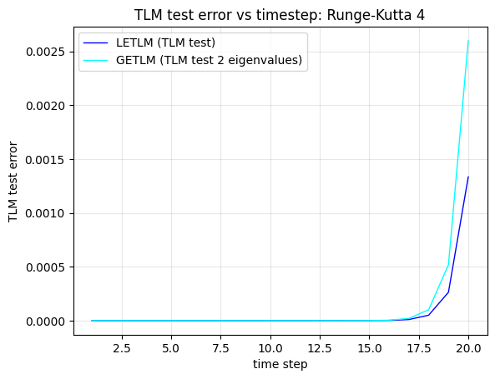
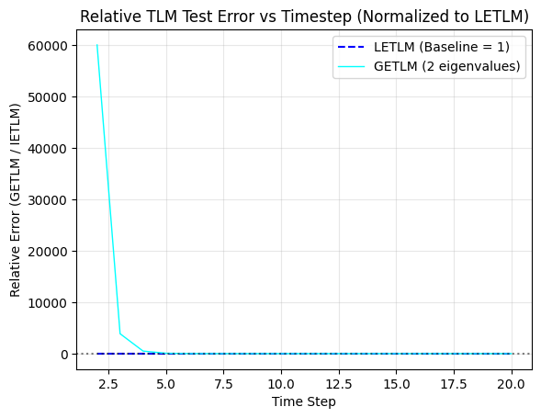

AB results
Stencils are
GETLM: [(-2,-1,0,1), (-2,-1,0,1), (-2,-1,0,1)]
IETLM: [(-2,-1,0,1), (-2,-1,0,1)]
LETLM: [(0),(-8,-7,-6,-5,-4,-3,-2,-1,0,1,2,3,4,5,6)]
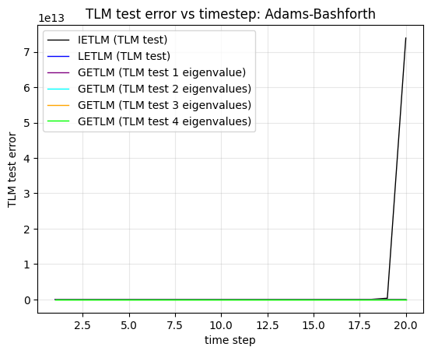
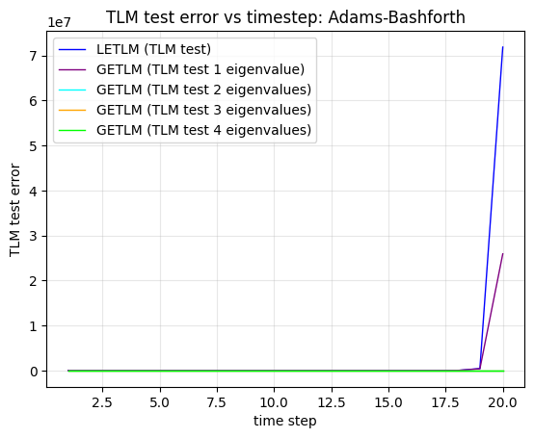

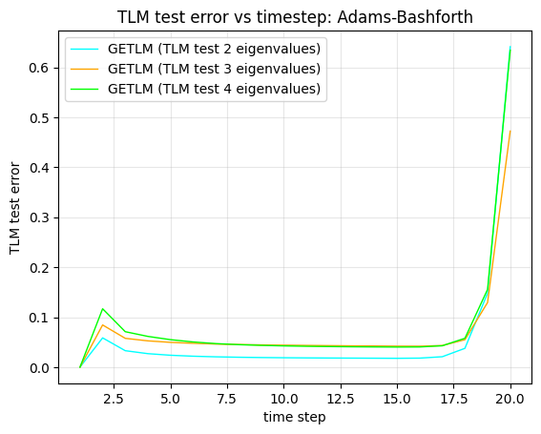
AB results
Stencils are
GETLM: [(-2,-1,0,1), ),(-8,-7,-6,-5,-4,-3,-2,-1,0,1,2,3,4,5,6), (-2,-1,0,1)]
IETLM: [(-2,-1,0,1), (-2,-1,0,1)]
LETLM: [(0),(-8,-7,-6,-5,-4,-3,-2,-1,0,1,2,3,4,5,6)]
